https://mirrors.estointernet.in/apache/tomcat/tomcat-8/v8.5.59/bin/apache-tomcat-8.5.59-windows-x64.ziphttps://mirrors.estointernet.in/apache/tomcat/tomcat-8/v8.5.59/bin/apache-tomcat-8.5.59-windows-x86.zip

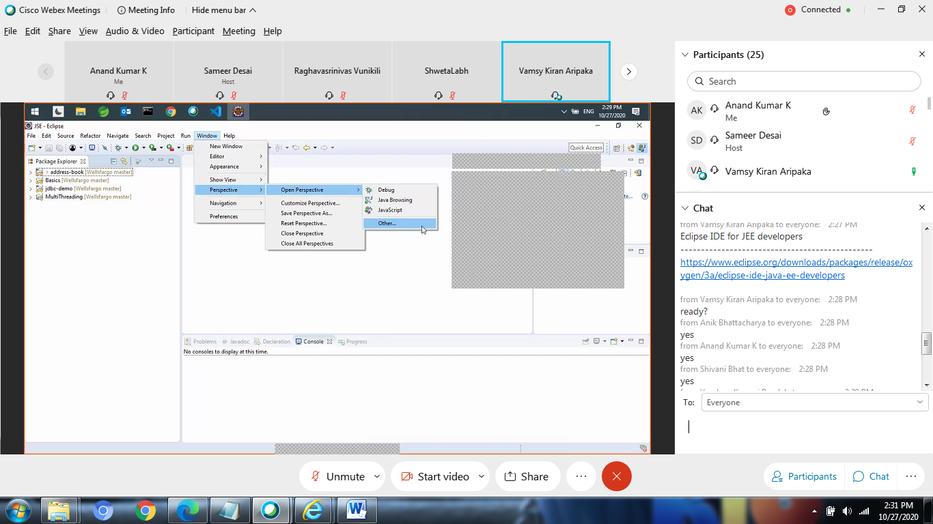



<https://www.eclipse.org/downloads/packages/release/oxygen/3a/eclipse-ide-java-ee-developers>

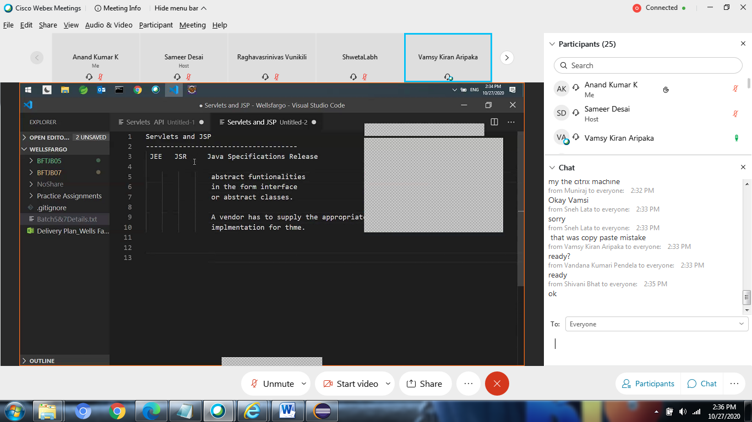

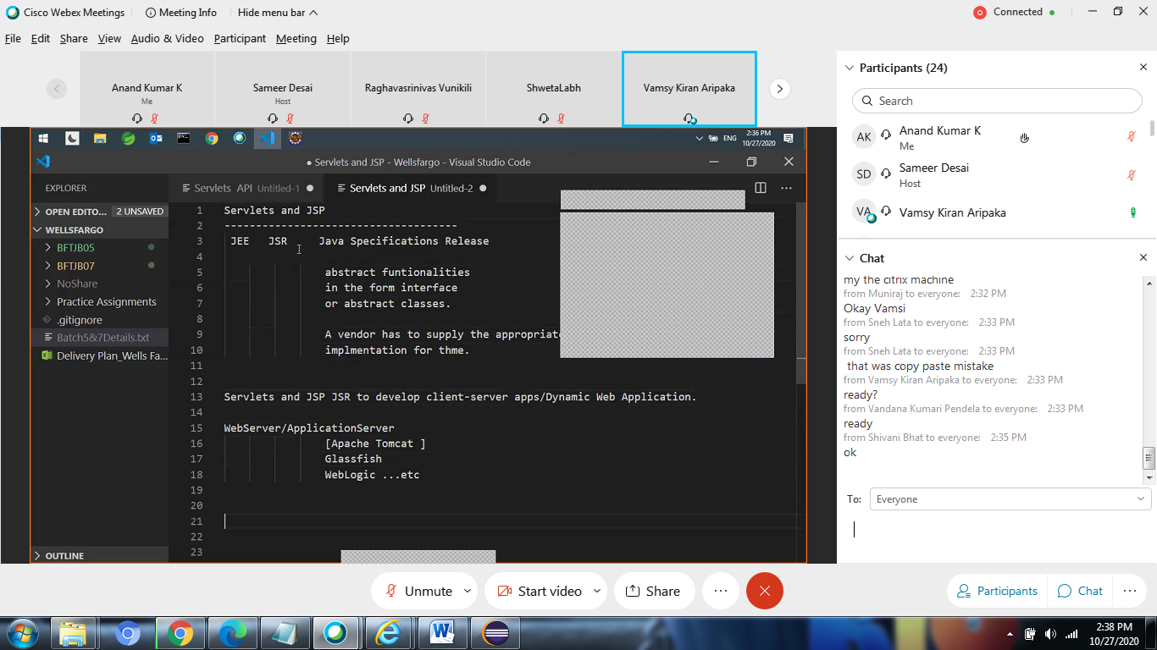

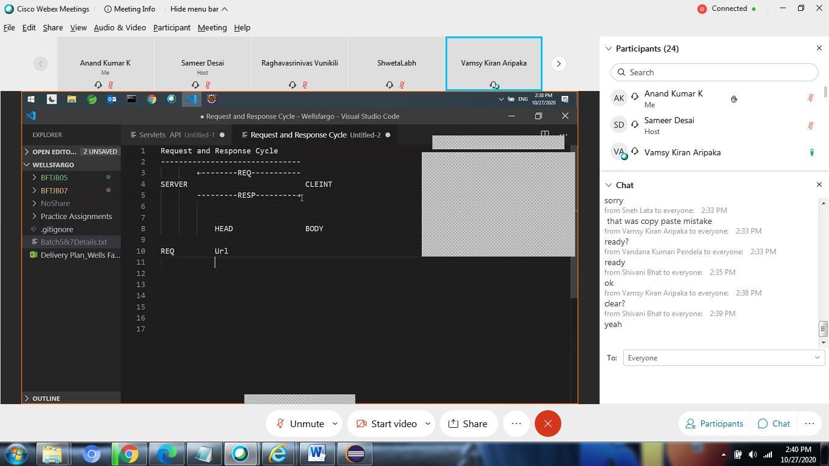

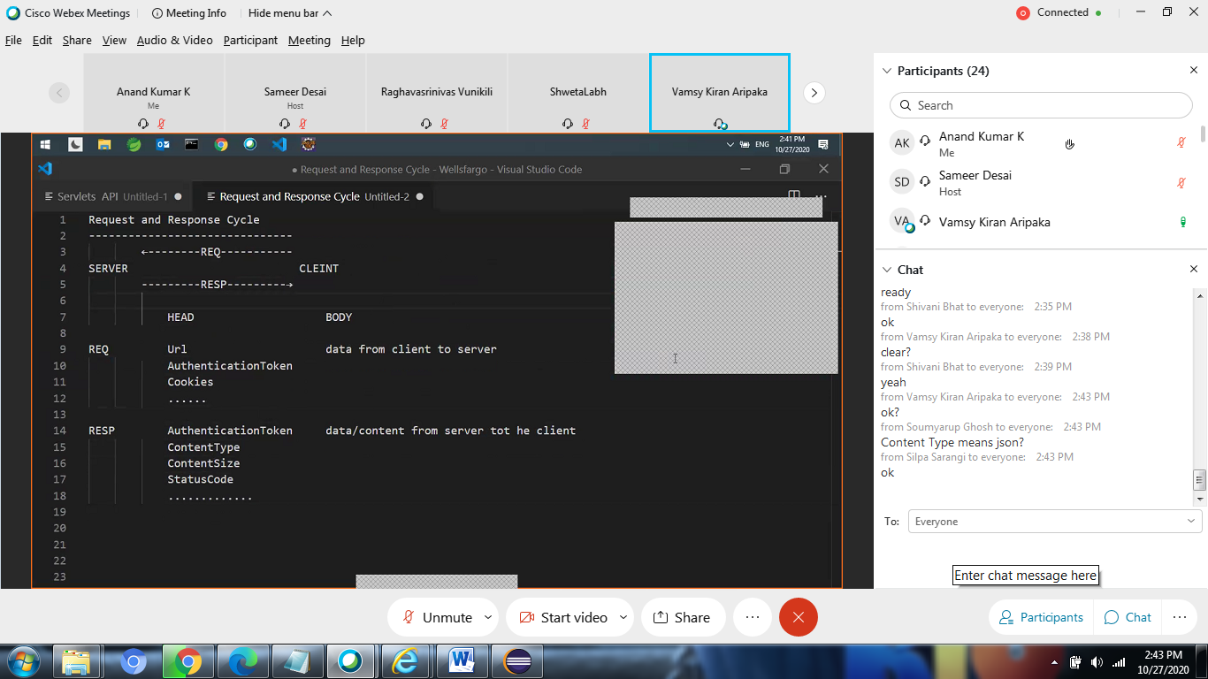

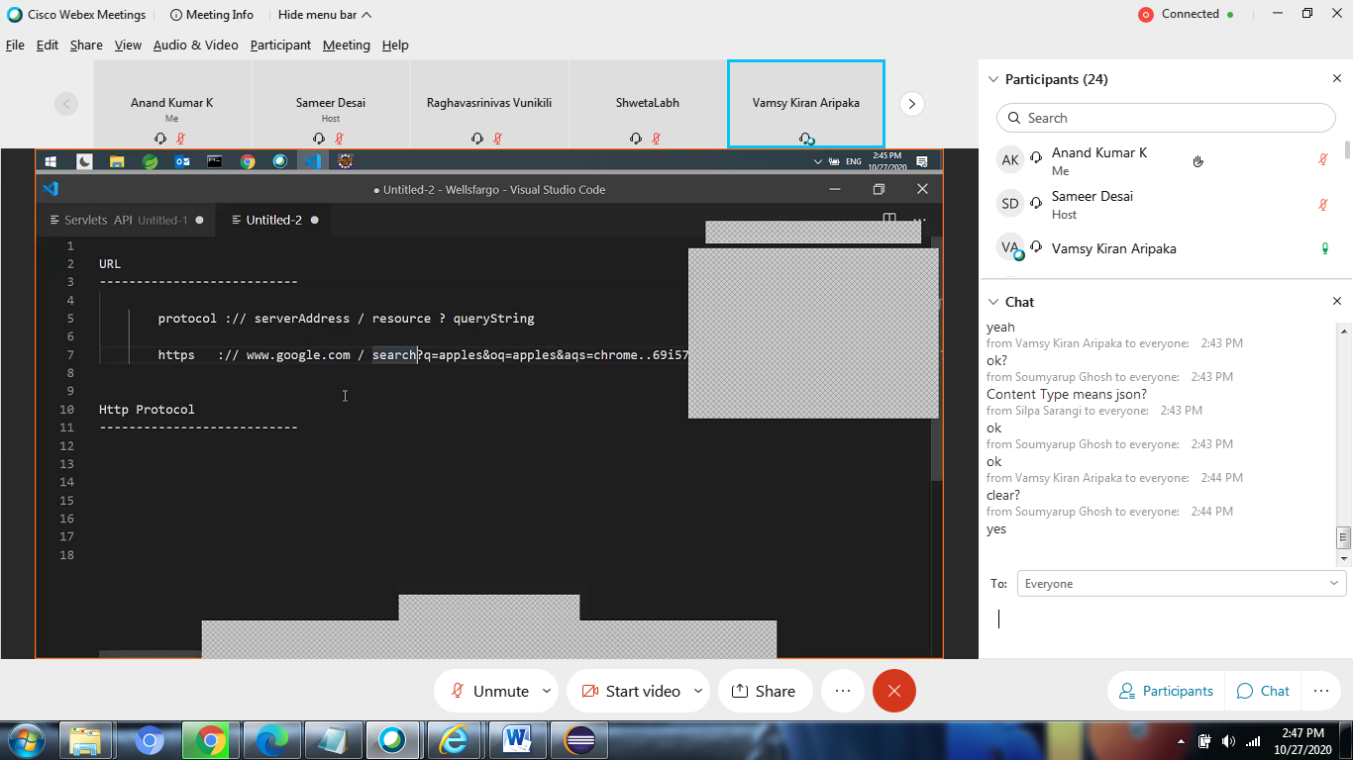

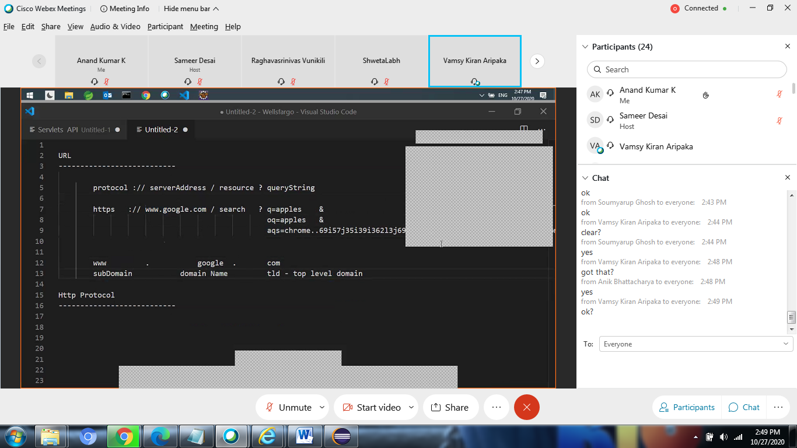

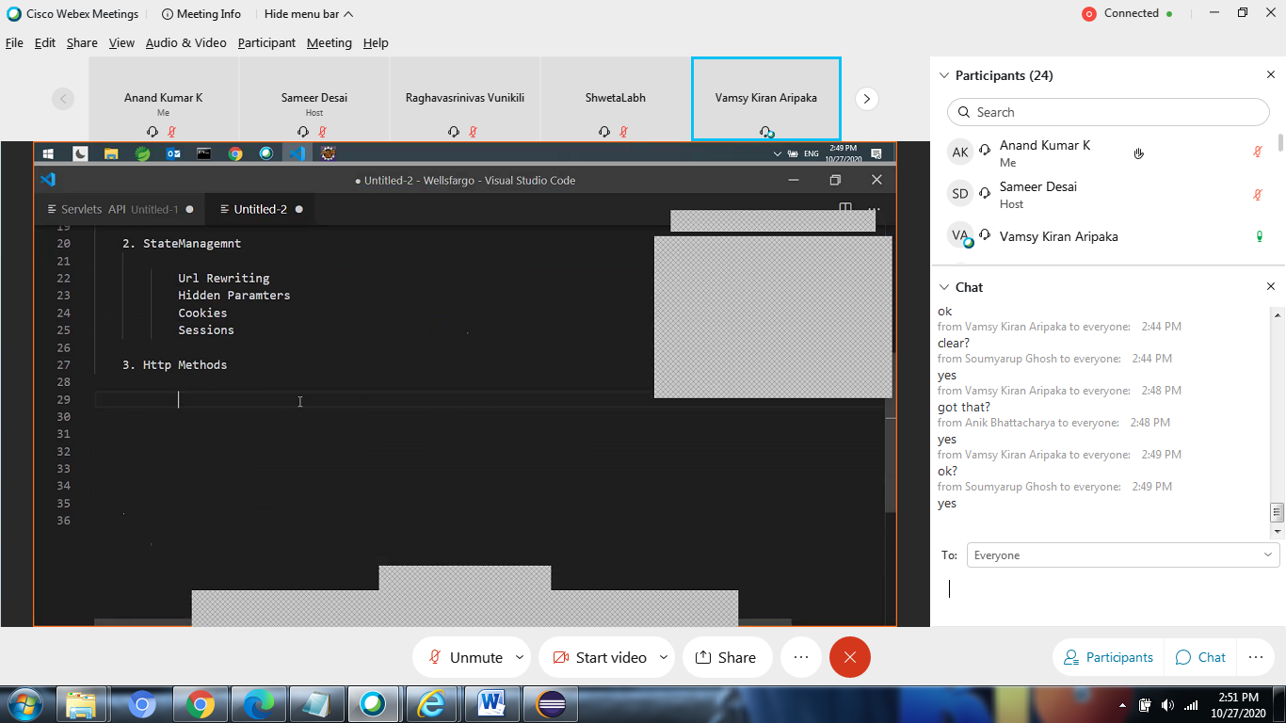

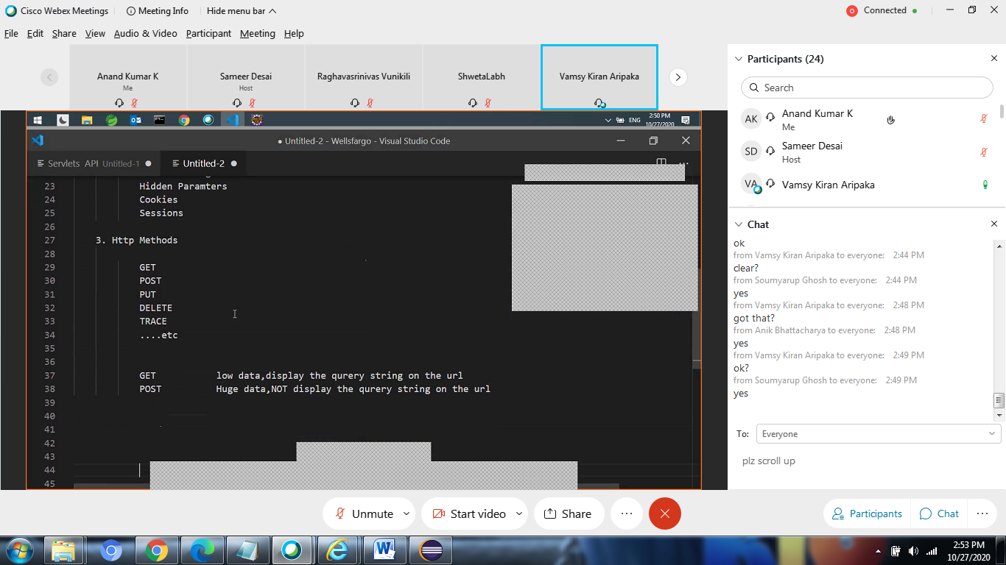

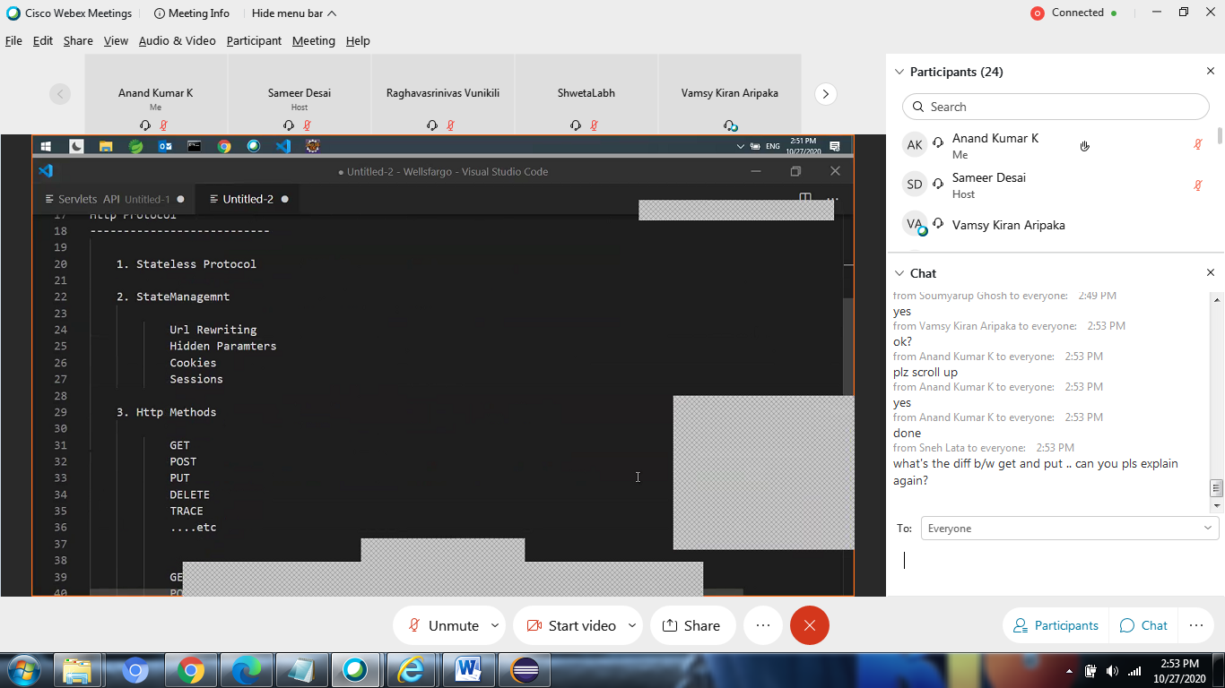

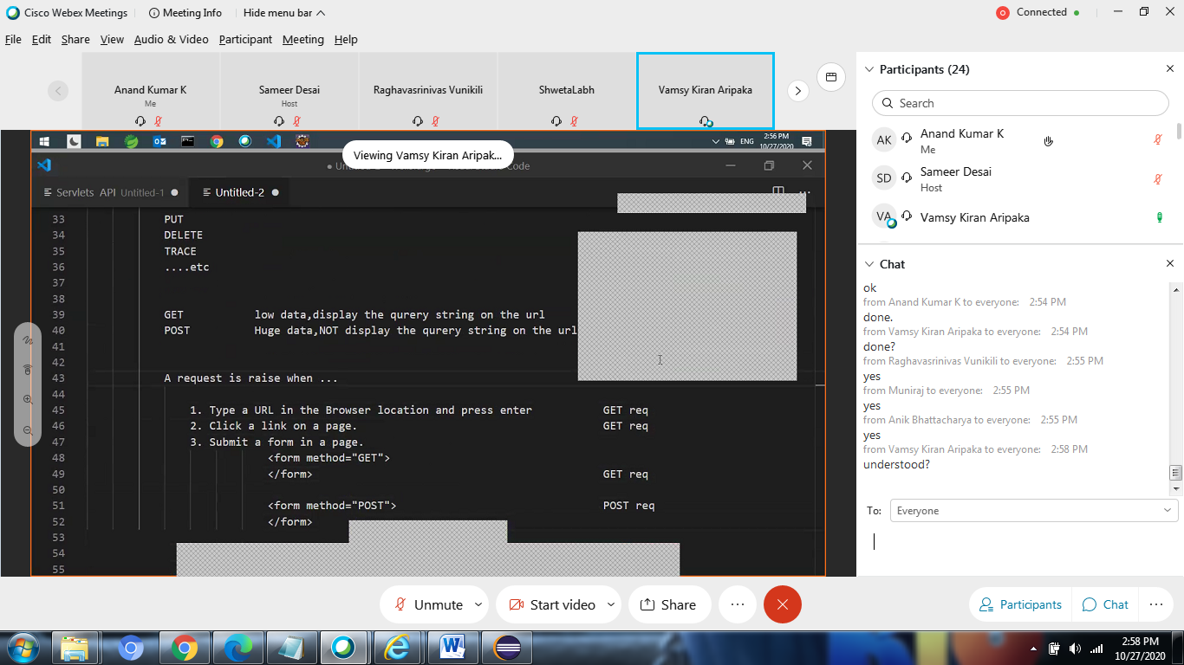

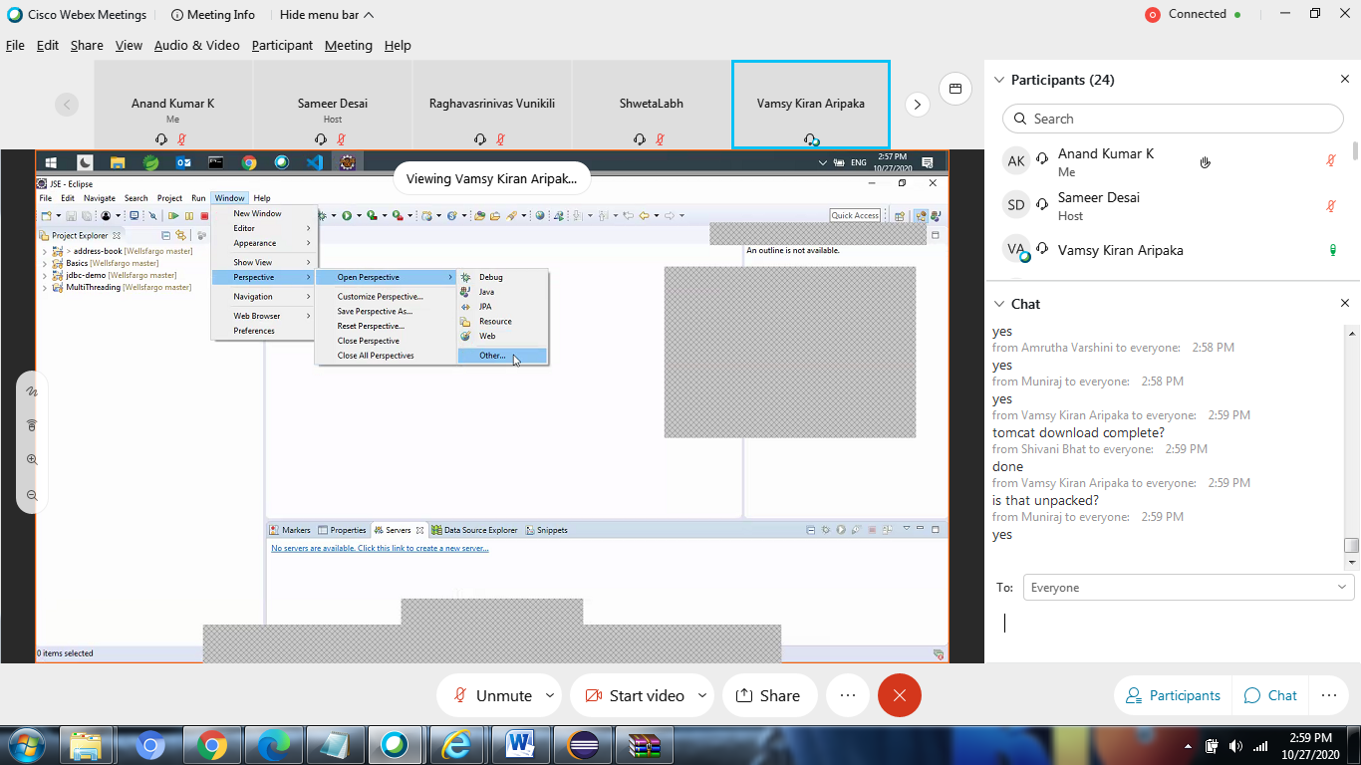

Server. Window riht click

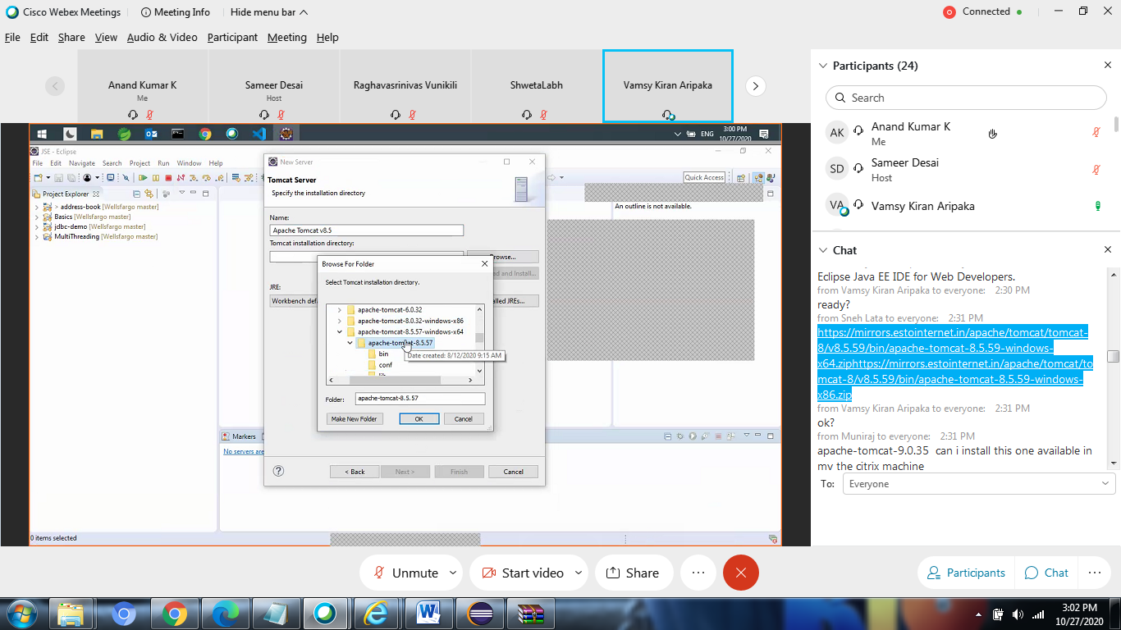

Slect apache contains bin

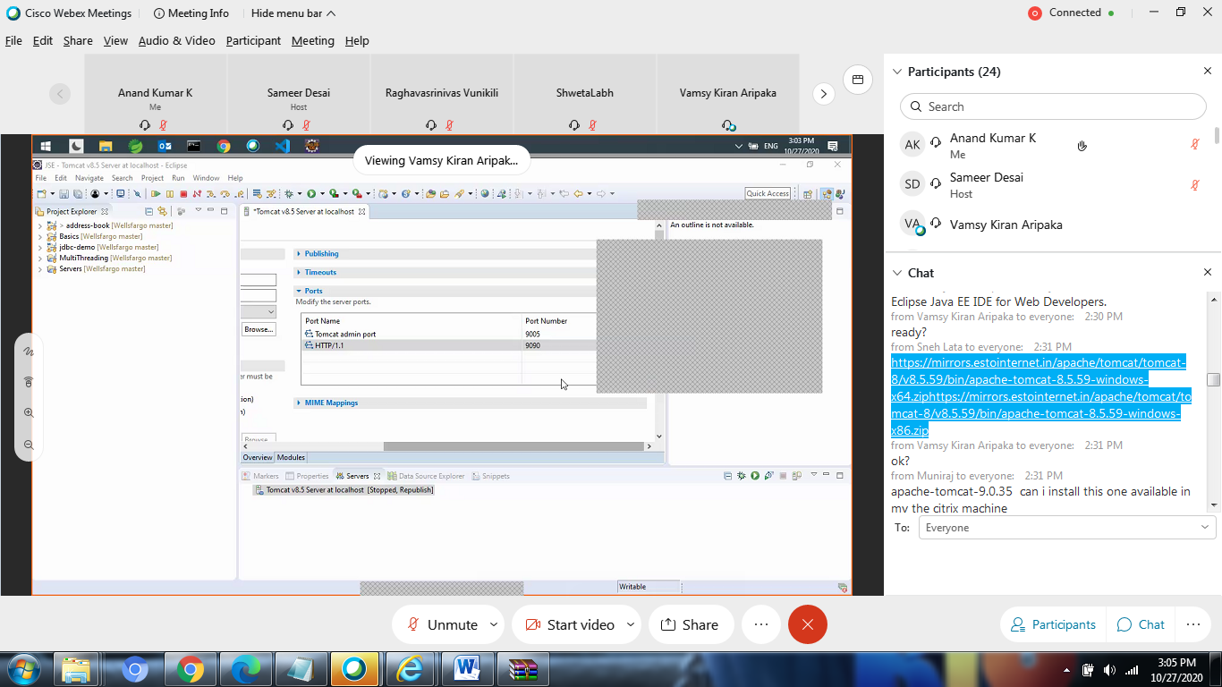

Right click on server and tstart

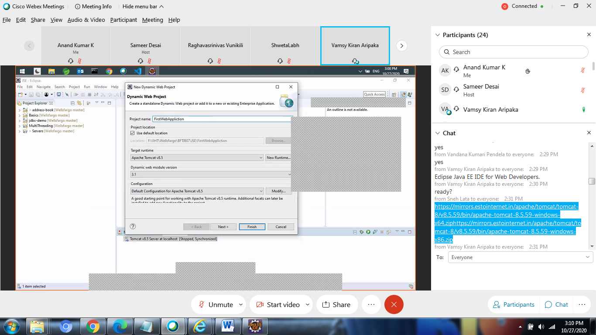

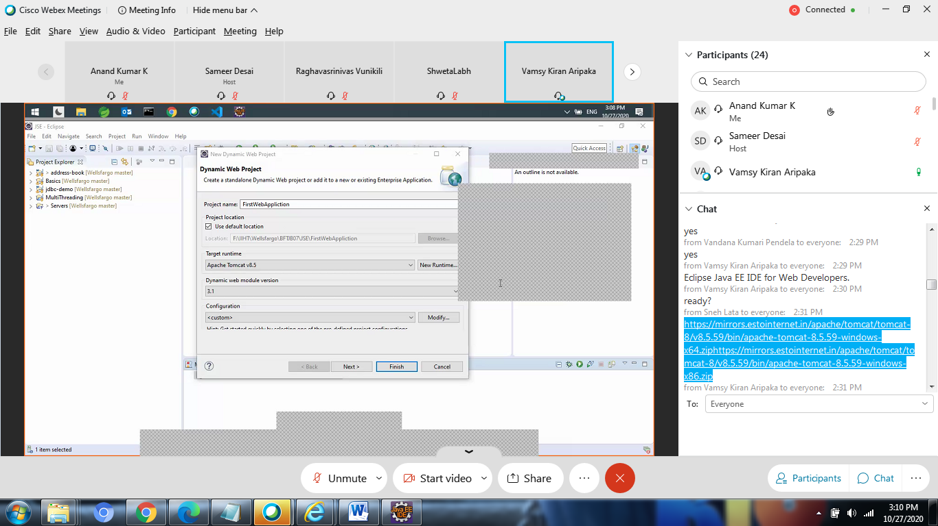

Right clivk configure configure to maven proj

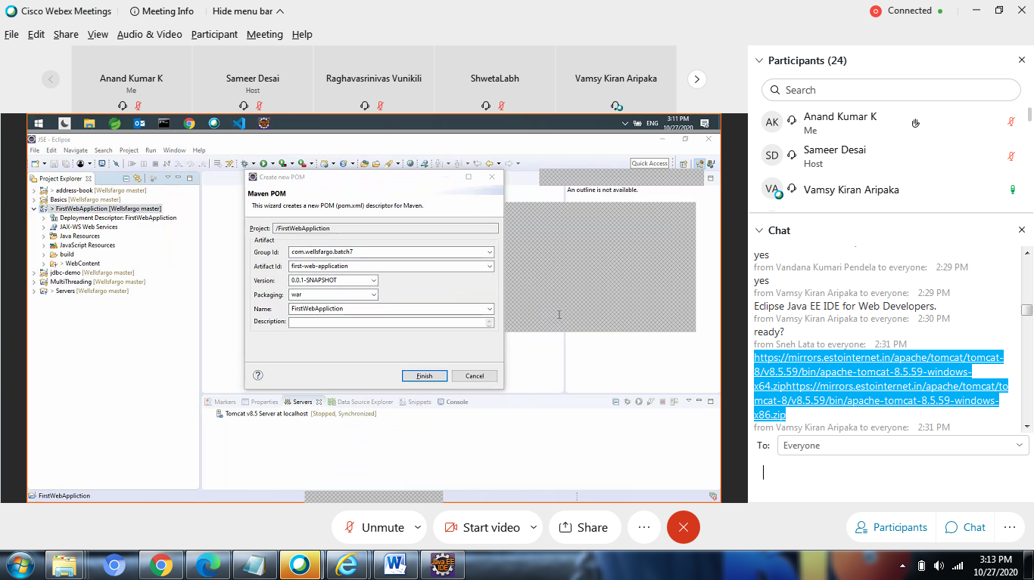

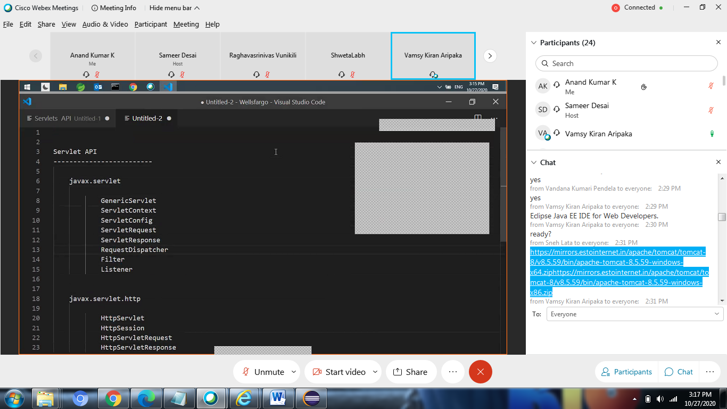

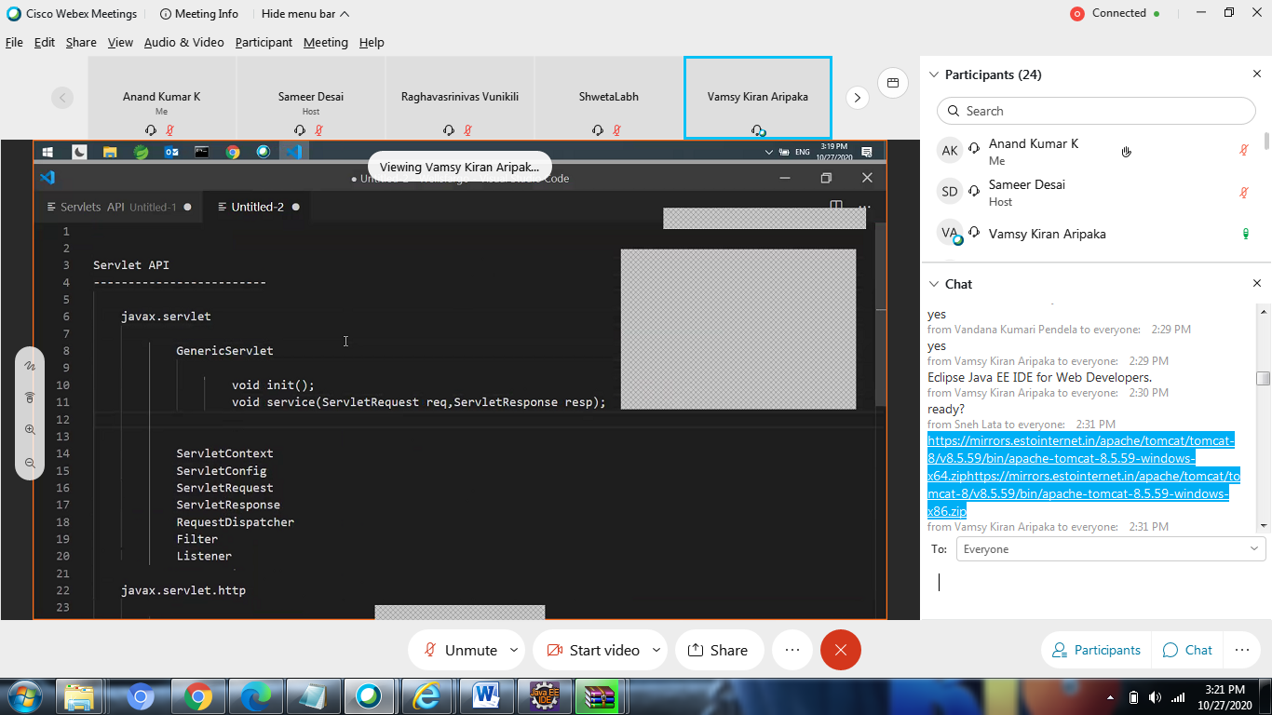

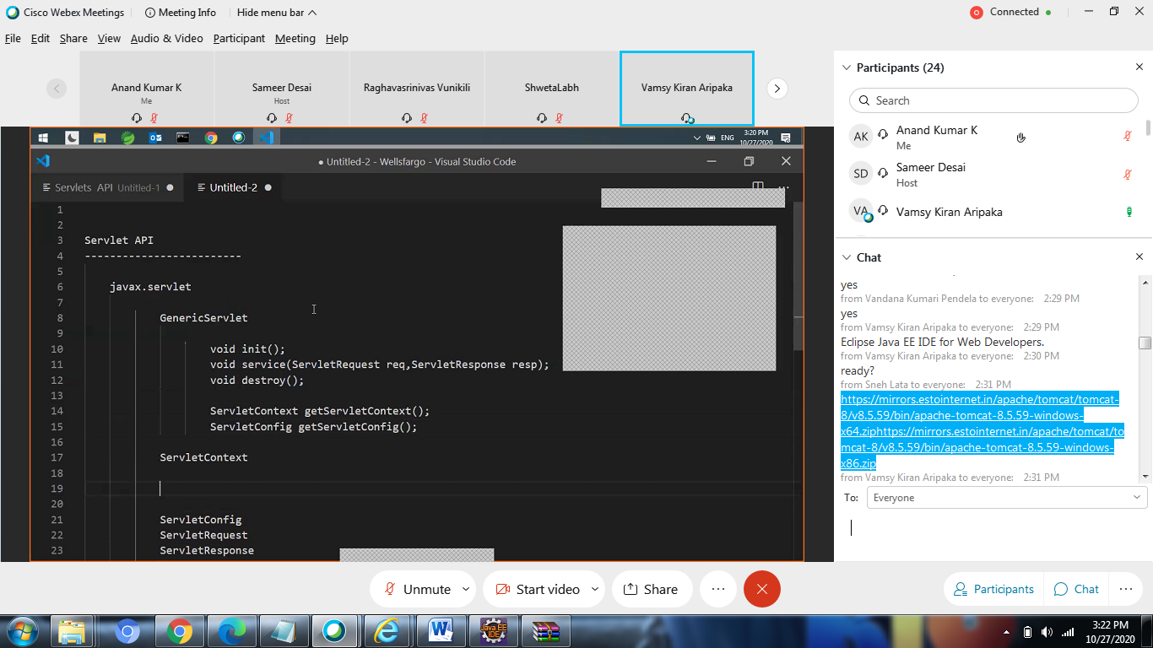

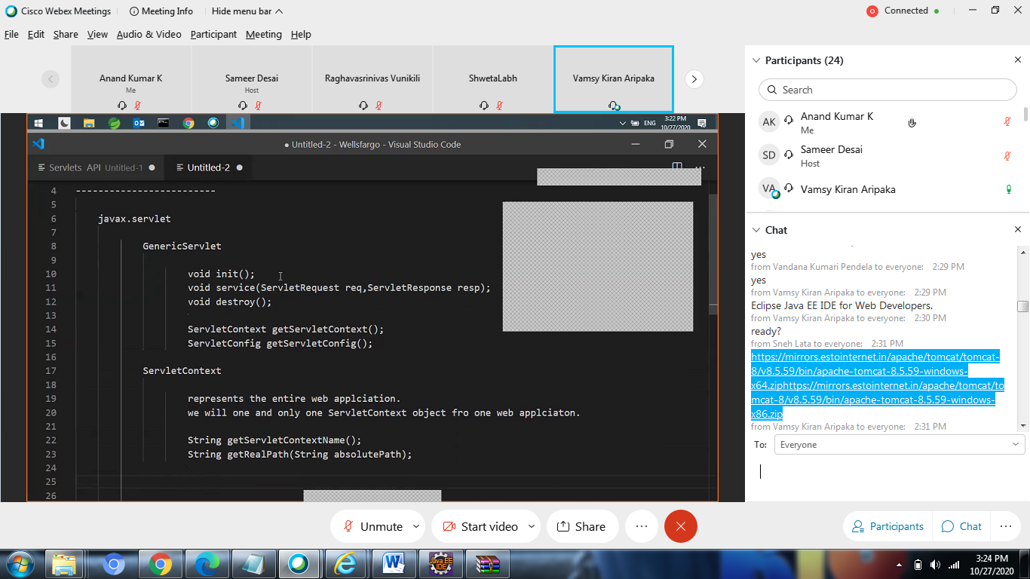

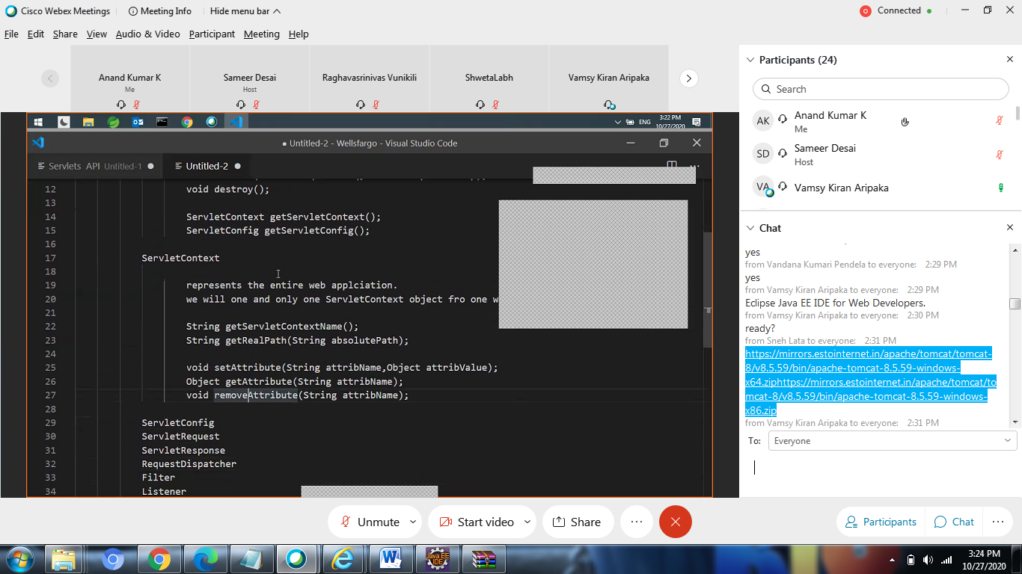

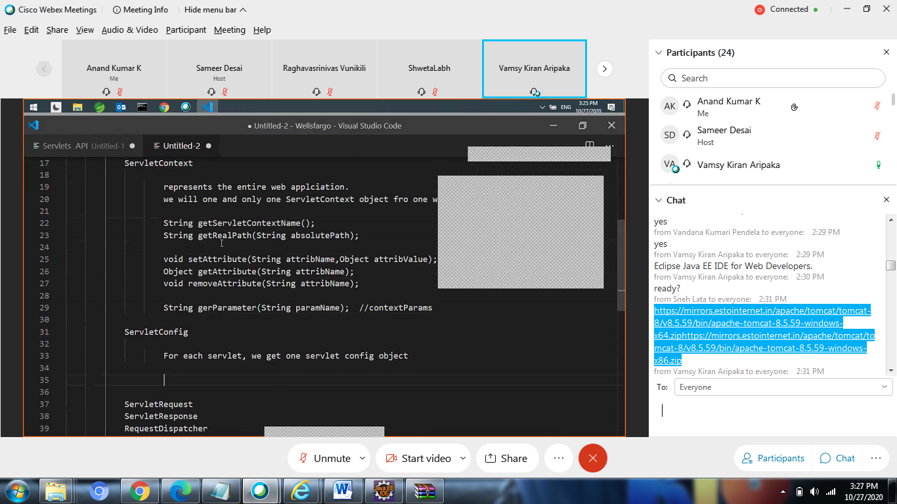

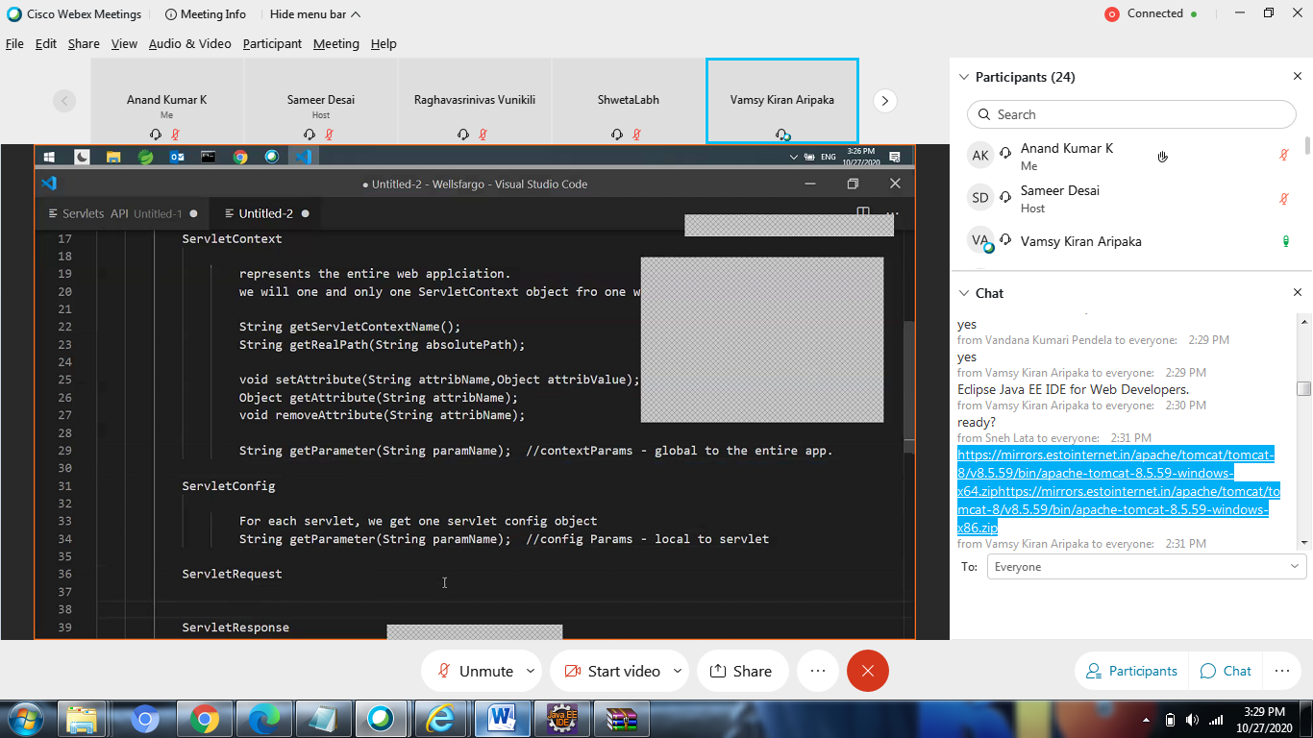

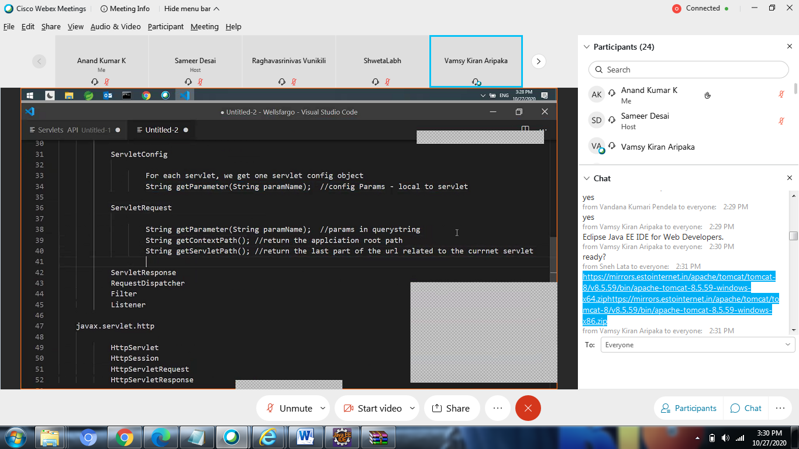

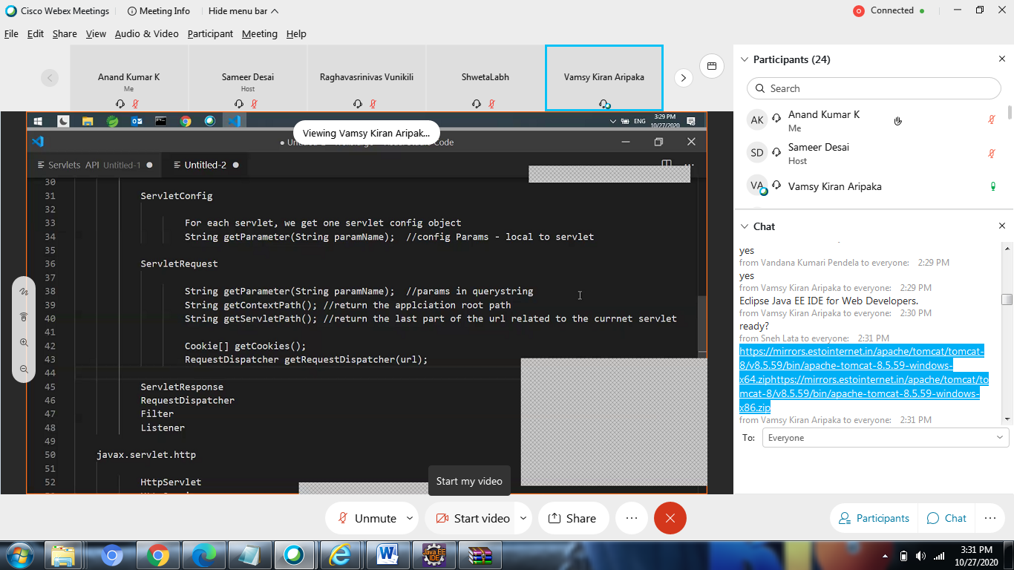

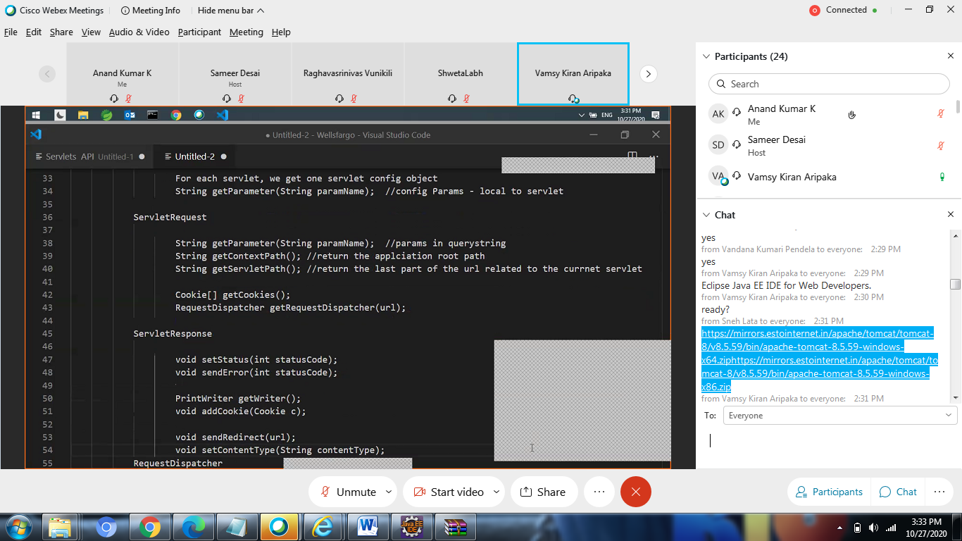

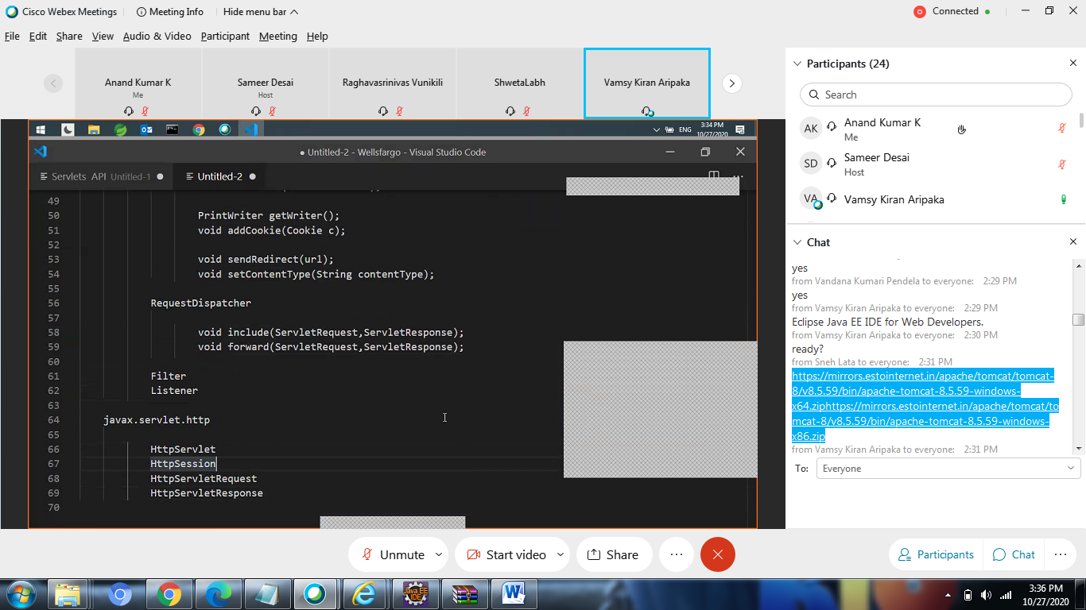

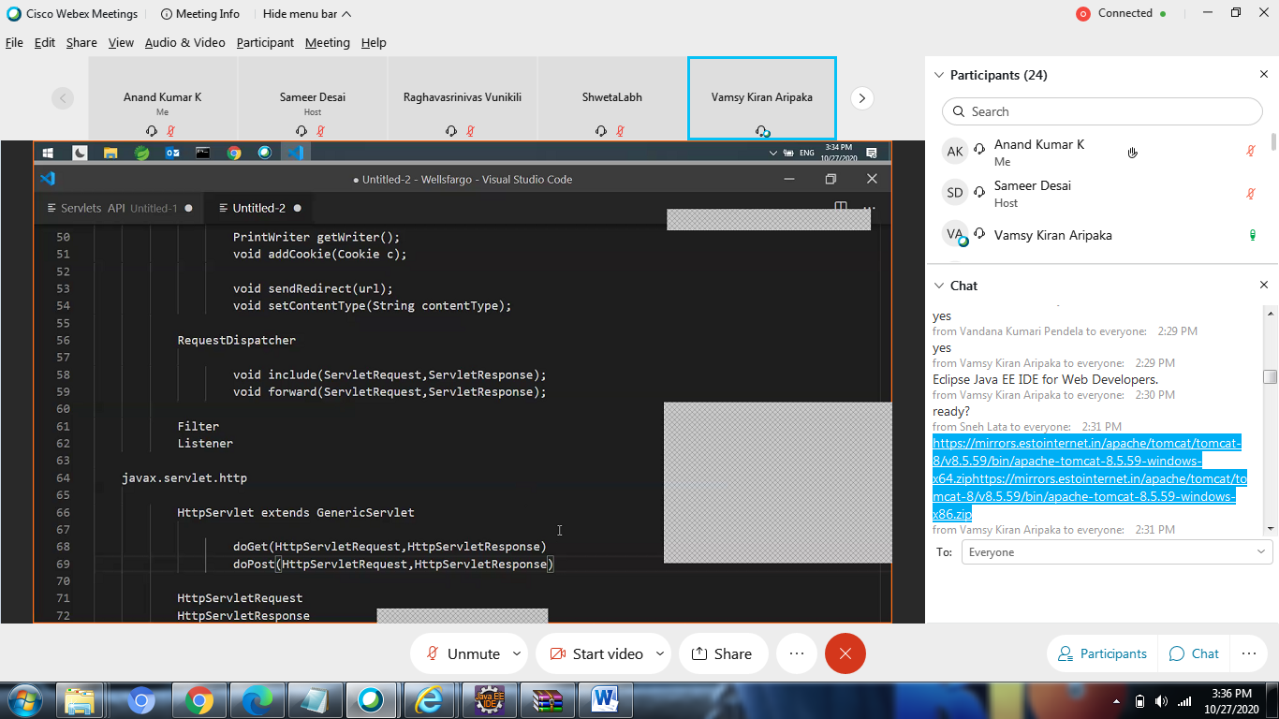

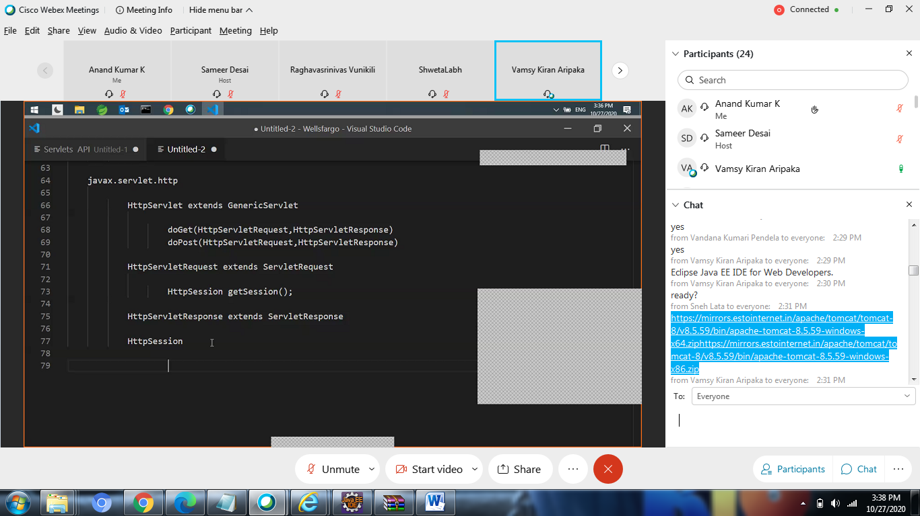

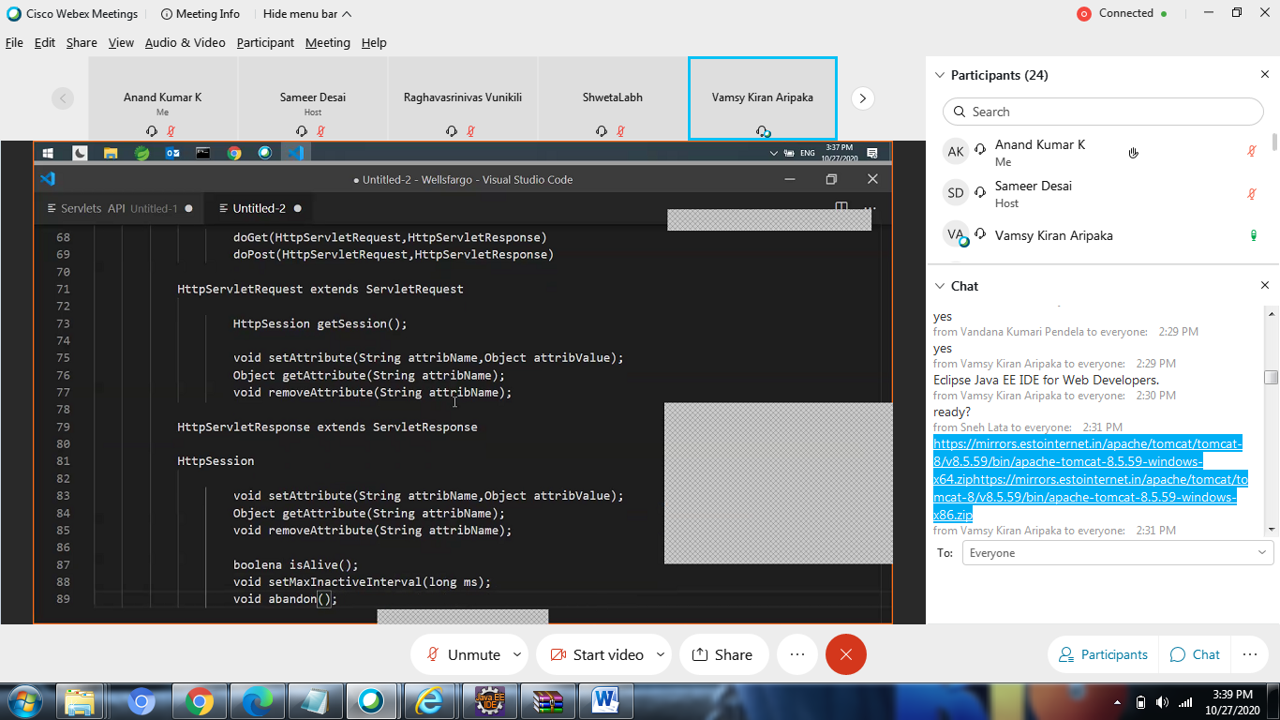

Servlet API------------------------- javax.servlet GenericServlet void init(); void service(ServletRequest req,ServletResponse resp); void destroy(); ServletContext getServletContext(); ServletConfig getServletConfig(); ServletContext represents the entire web applciation. we will one and only one ServletContext object fro one web applciaton. String getServletContextName(); String getRealPath(String absolutePath); void setAttribute(String attribName,Object attribValue); Object getAttribute(String attribName); void removeAttribute(String attribName); String getParameter(String paramName); //contextParams - global to the entire app.

from Vamsy Kiran Aripaka to everyone: 3:45 PM

ServletConfig For each servlet, we get one servlet config object String getParameter(String paramName); //config Params - local to servlet ServletRequest String getParameter(String paramName); //params in querystring String getContextPath(); //return the applciation root path String getServletPath(); //return the last part of the url related to the currnet servlet Cookie[] getCookies(); RequestDispatcher getRequestDispatcher(url);

from Vamsy Kiran Aripaka to everyone: 3:45 PM

ServletResponse void setStatus(int statusCode); void sendError(int statusCode); PrintWriter getWriter(); void addCookie(Cookie c); void sendRedirect(url); void setContentType(String contentType); RequestDispatcher void include(ServletRequest,ServletResponse); void forward(ServletRequest,ServletResponse); Filter Listener

from Vamsy Kiran Aripaka to everyone: 3:45 PM

javax.servlet.http HttpServlet extends GenericServlet doGet(HttpServletRequest,HttpServletResponse) doPost(HttpServletRequest,HttpServletResponse) HttpServletRequest extends ServletRequest HttpSession getSession(); void setAttribute(String attribName,Object attribValue); Object getAttribute(String attribName); void removeAttribute(String attribName);

from Vamsy Kiran Aripaka to everyone: 3:45 PM

HttpServletResponse extends ServletResponse HttpSession void setAttribute(String attribName,Object attribValue); Object getAttribute(String attribName); void removeAttribute(String attribName); boolean isAlive(); void setMaxInactiveInterval(long ms); void abandon(); HttpServletResponse extends ServletResponse HttpSession void setAttribute(String attribName,Object attribValue); Object getAttribute(String attribName); void removeAttribute(String attribName); boolean isAlive(); void setMaxInactiveInterval(long ms); void abandon();